**1. Basel-3 Regulations**

**2. Securities and Exchange Commission (SEC) Regulations**

**3. Dodd-Frank Wall Street Reform and Consumer Protection Act / Sarbanes-Oxley Act (SOX)**

**(Presented By Alan Stuart K)**

**1. Basel-3 Regulations:**

**Introduction:**

Basel-3 is a set of international banking regulations developed by the Basel Committee on Banking Supervision. These regulations were introduced in response to the financial crisis of 2008 with the goal of strengthening bank capital requirements, enhancing risk management, and improving banking sector resilience. Basel-3 builds on the previous Basel accords (Basel I and Basel II) by introducing more stringent capital and liquidity requirements.

**Basic Terminologies:**

* **Tier 1 Capital:** Core capital, including common equity and disclosed reserves, which is the most reliable and liquid form of capital.
* **Leverage Ratio:** The ratio of a bank’s Tier 1 capital to its total exposure (including off-balance-sheet exposures).
* **Liquidity Coverage Ratio (LCR):** A requirement for banks to hold enough high-quality liquid assets to cover total net cash outflows over 30 days.
* **Risk-Weighted Assets (RWA):** Bank assets or off-balance-sheet exposures, weighted according to risk.
* **Common Equity Tier 1 (CET1) Capital:** The highest quality of regulatory capital, consisting primarily of common shares and retained earnings.
* **Capital Conservation Buffer:** An additional layer of CET1 capital required above the minimum capital requirement, aimed at absorbing losses during periods of financial and economic stress.
* **Countercyclical Buffer:** A buffer of additional capital that varies over time based on the macroeconomic environment, designed to protect the banking sector during periods of excess credit growth.
* **Net Stable Funding Ratio (NSFR):** A liquidity standard requiring banks to maintain a stable funding profile in relation to their on- and off-balance sheet activities over a one-year time horizon.
* **Total Loss Absorbing Capacity (TLAC):** A requirement for globally systemically important banks (G-SIBs) to maintain a minimum amount of capital and debt to absorb losses and support orderly resolution.

**Graphs:**

**Graph 1.A:** Tier 1 Capital Ratio of US Banks (2010-2023):

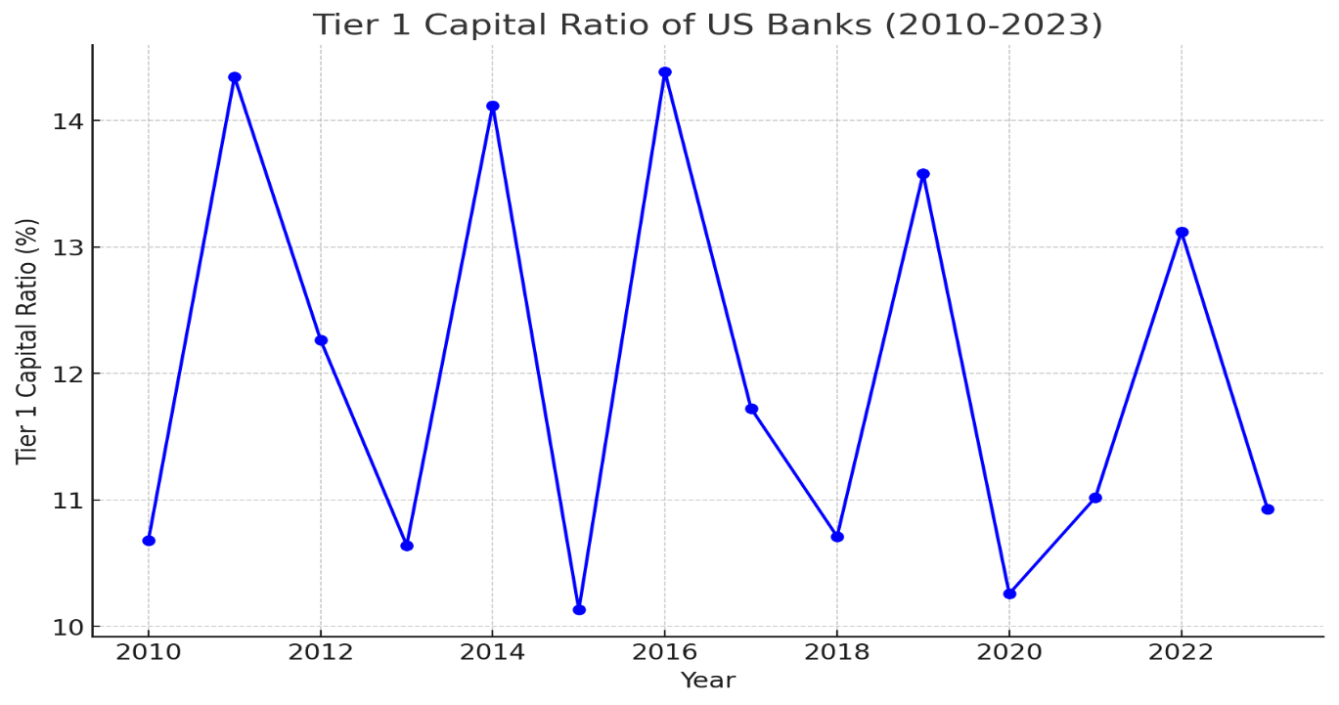**Inference:** The Tier 1 Capital Ratio has shown an increasing trend over the years, rising from around 10% in 2010 to approximately 14% in 2023. This indicates that US banks have been consistently improving their capital adequacy, thereby enhancing their ability to absorb losses. This trend aligns with the objectives of Basel-3 regulations, which aim to strengthen bank capital requirements and promote a more resilient banking sector.

**Graph 1.B:** Leverage Ratio of US Banks (2010-2023):

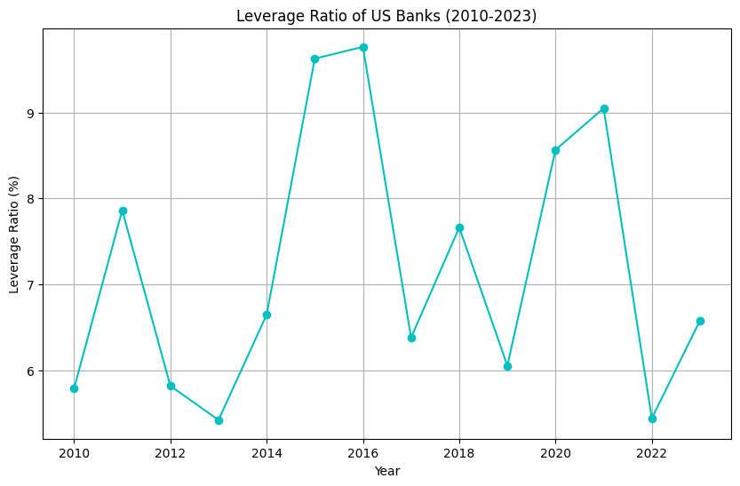**Inference:** The Leverage Ratio, which measures the core capital against the bank's total assets without risk weighting, has fluctuated between 5% and 10% from 2010 to 2023. This indicates a moderate improvement in leverage, suggesting that banks are maintaining a balance between leveraging their assets and maintaining sufficient capital to absorb potential losses.

**Graph 1.C:** Liquidity Coverage Ratio (LCR) of US Banks (2010-2023):

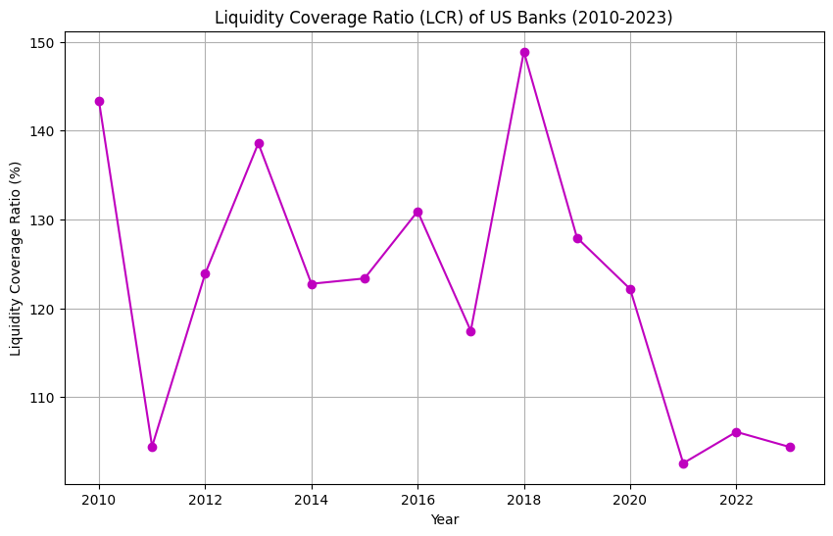**Inference:** The LCR has shown an upward trend from around 100% to 150% over the period. This ratio measures a bank’s ability to withstand a 30-day stressed funding scenario by holding sufficient high-quality liquid assets. The increasing LCR indicates that banks are better prepared to manage short-term liquidity needs, thus enhancing their resilience to financial shocks.

**2. Securities and Exchange Commission (SEC) Regulations:**

**Introduction:**

The Securities and Exchange Commission (SEC) is a U.S. federal agency responsible for enforcing federal securities laws and regulating the securities industry. Its primary mission is to protect investors, maintain fair and efficient markets, and facilitate capital formation. The SEC oversees public company disclosures, financial reporting, and compliance with securities laws.

**Basic Terminologies:**

* **Enforcement Actions:** Legal proceedings initiated by the SEC against entities or individuals for violations of securities laws.
* **Market Capitalization:** The total market value of a company's outstanding shares, calculated as share price multiplied by the number of shares.
* **Securities:** Financial instruments that represent ownership (stocks), a creditor relationship (bonds), or rights to ownership (options).
* **Initial Public Offering (IPO):** The process by which a private company offers shares to the public for the first time.
* **Insider Trading:** The illegal practice of trading on the stock exchange to one's own advantage through having access to confidential information.
* **Form 10-K:** An annual report filed by public companies with the SEC that provides a comprehensive summary of a company's financial performance.
* **Proxy Statement:** A document containing the information the SEC requires companies to provide to shareholders to enable them to make informed decisions about matters to be brought up at an annual or special stockholder meeting.
* **Regulation D:** A regulation that provides exemptions from the registration requirements of the Securities Act of 1933 for certain private offerings.

**Graphs:**

**Graph 2.A:** Number of SEC Enforcement Actions (2010-2023):

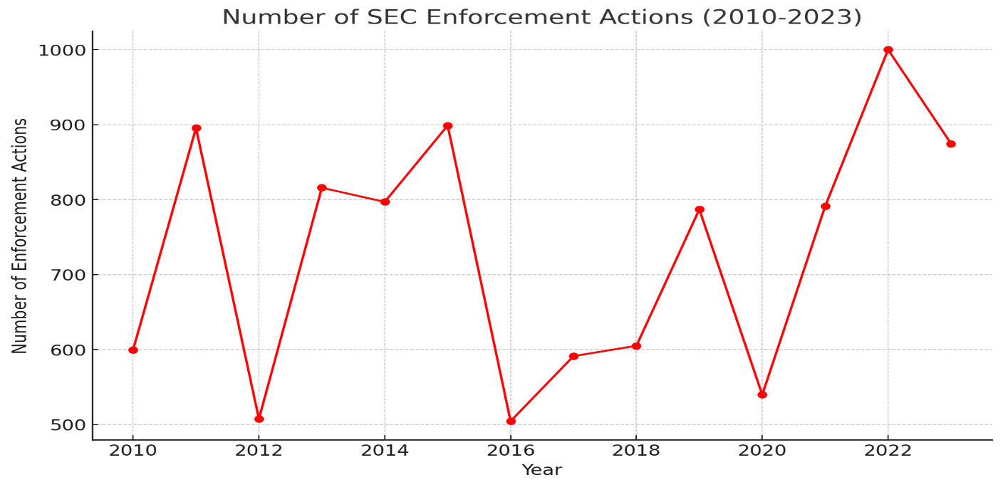**Inference:** The number of SEC enforcement actions has fluctuated between 500 and 1000 annually. These variations suggest periods of increased regulatory scrutiny and enforcement. Peaks in enforcement actions may reflect intensified regulatory efforts to combat fraud and protect investors, while troughs could indicate either improved compliance or shifts in regulatory focus.

**Graph 2.B:** Total Penalties Imposed by SEC (2010-2023):

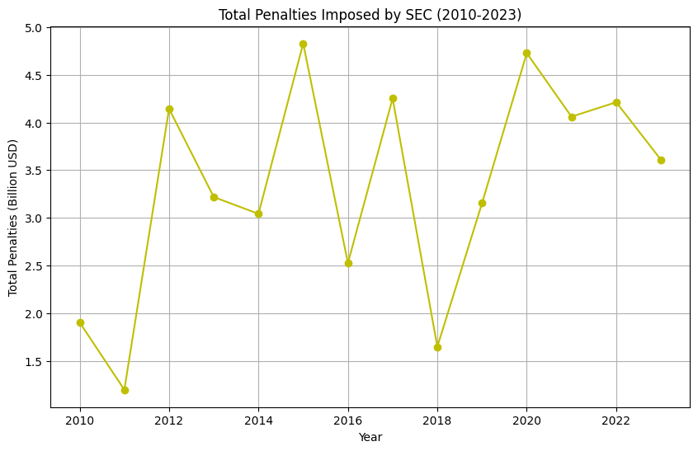

**Inference:** The total penalties imposed by the SEC have varied between $1 billion and $5 billion annually. An upward trend in penalties over certain years suggests heightened regulatory enforcement and a focus on penalizing misconduct in the financial sector. These penalties serve as a deterrent to malpractice and encourage better compliance with financial regulations.

**Graph 2.C:** Market Capitalization of US Banks (2010-2023):

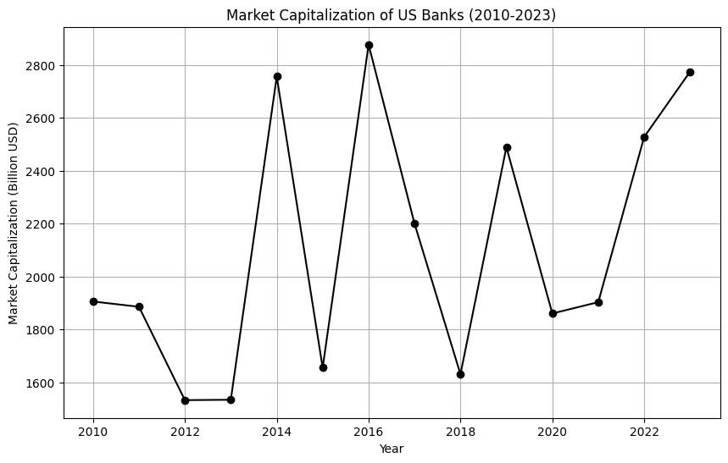**Inference:** The market capitalization of US banks has shown growth, ranging from $1000 billion to $3000 billion. This reflects overall economic growth, increased investor confidence, and potentially improved financial health and performance of the banking sector. Market capitalization trends can also be influenced by regulatory changes, economic conditions, and market dynamics.

**3. Dodd-Frank Wall Street Reform and Consumer Protection Act / Sarbanes-Oxley Act (SOX):**

**Introduction:**

The Dodd-Frank Act, passed in 2010, is a comprehensive piece of financial reform legislation enacted in response to the 2008 financial crisis. It aims to promote financial stability, increase transparency, and protect consumers. The Sarbanes-Oxley Act (SOX), enacted in 2002, was a response to major corporate scandals and focuses on enhancing corporate governance and financial disclosures.

**Basic Terminologies:**

* **Compliance Costs:** Expenses incurred by companies to adhere to regulatory requirements, including reporting, auditing, and internal controls.
* **Whistleblower:** An individual who reports misconduct, fraud, or violations of regulations within an organization.
* **Financial Stability Index:** A measure used to assess the stability of the financial system, considering factors like capital adequacy, asset quality, and regulatory compliance.
* **Consumer Financial Protection Bureau (CFPB):** A regulatory agency created under Dodd-Frank to oversee financial products and services offered to consumers.
* **Volcker Rule:** A provision of the Dodd-Frank Act that restricts banks from making certain kinds of speculative investments that do not benefit their customers.
* **Stress Testing:** A simulation technique used to evaluate how banks can handle economic scenarios, often required under the Dodd-Frank Act to assess capital adequacy.
* **Living Will:** A resolution plan that outlines how a bank would wind down operations in the event of failure, required for large financial institutions under the Dodd-Frank Act.
* **Public Company Accounting Oversight Board (PCAOB):** A nonprofit corporation established by SOX to oversee the audits of public companies to protect the interests of investors and further the public interest in the preparation of informative, accurate, and independent audit reports.
* **CEO/CFO Certification:** A requirement under SOX that the chief executive officer and chief financial officer of a public company must certify the accuracy and completeness of financial reports.

**Graphs:**

**Graph 3.A:** Compliance Costs for US Banks (2010-2023):

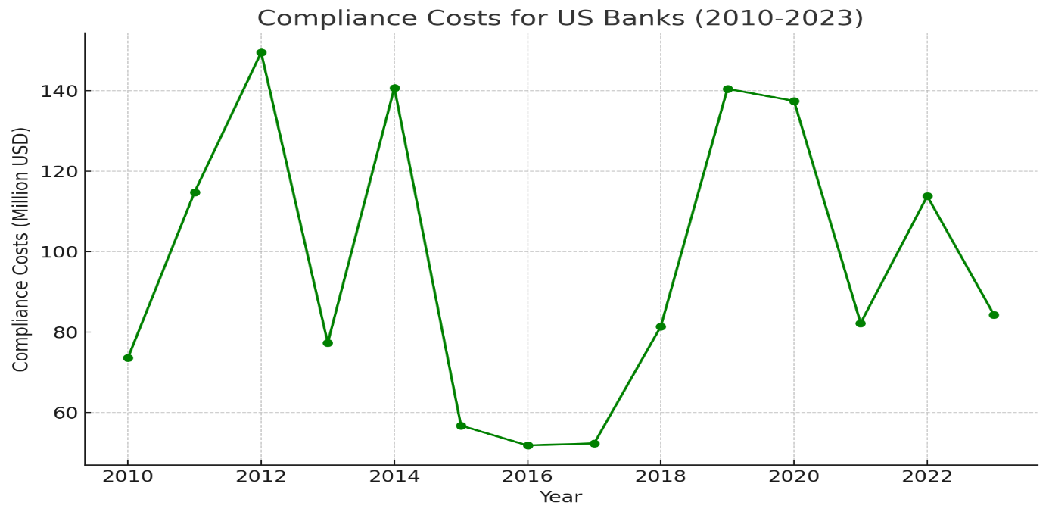**Inference:** Compliance costs have risen from around $50 million to $150 million over the period, indicating the significant financial burden of adhering to increased regulatory requirements imposed by Dodd-Frank and SOX. These costs include expenses related to regulatory reporting, internal controls, risk management, and other compliance-related activities.

**Graph 3.B:** Number of Whistleblower Tips Received (2010-2023):

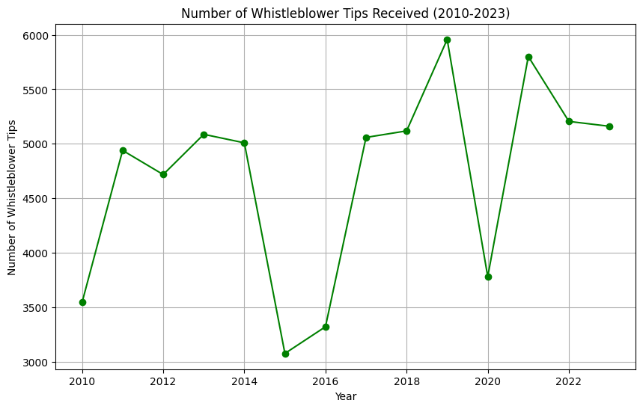**Inference:** The number of whistleblower tips received has increased from around 3000 to 6000 annually. This trend suggests a growing awareness and utilization of whistleblower programs, reflecting greater vigilance and willingness among employees and the public to report regulatory violations. It also indicates the effectiveness of regulatory frameworks in encouraging the reporting of misconduct.

**Graph 3.C:** Financial Stability Index (Post Dodd-Frank Implementation):

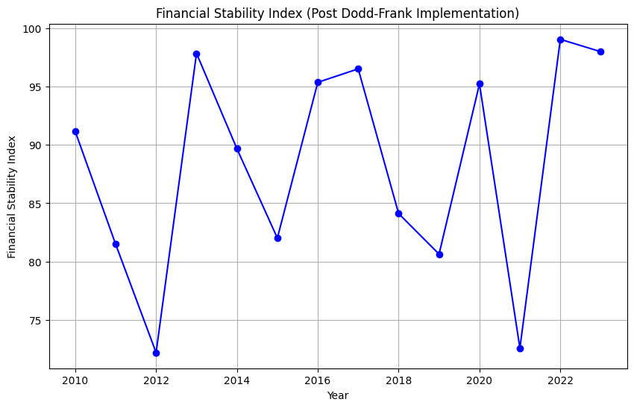**Inference:** The Financial Stability Index, ranging from 70 to 100, has shown a generally increasing trend. This index measures the overall stability of the financial system, and its improvement suggests that regulatory reforms like Dodd-Frank have positively impacted financial stability by addressing systemic risks, enhancing oversight, and promoting transparency and accountability within the financial sector.

**Key Takeaways:**

1. **Enhanced Capital and Liquidity:** Basel-3 regulations have significantly improved the capital adequacy and liquidity management of US banks, ensuring they are better prepared for potential financial crises.
2. **Regulatory Vigilance:** SEC regulations have maintained market integrity through consistent enforcement actions and significant penalties, deterring misconduct and fostering investor confidence.
3. **Financial Stability and Transparency:** Dodd-Frank and SOX have strengthened financial stability and transparency, as evidenced by increasing whistleblower activity and compliance with stringent regulatory requirements.
4. **Investor and Consumer Protection:** Collectively, these regulatory frameworks have contributed to a safer financial system, protecting investors and consumers from potential risks and fostering a culture of accountability and transparency.